[Mastt Project]

Progress Report



Information Technology Capstone Project

COMP5703

Group Members

Fan Gao (480099589)

Xinyu Hu(470475340)

Tianming Chen(470197372)

Ziyun Chen (480337997)

Yili Wang (470106260)

**Table Of Contents**

**1. Progress Status** **3**

**2. Roles & Responsibilities** **6**

**3. Individual Achievements** **8**

**4. Group Collaboration** **10**

# 

# **1.** **Progress Status**

|  |  |
| --- | --- |
| **Project Name** | Mastt Project |
| **Project Start Date** | 14/AUG/2019 |
| **Project Manager** | Fan Gao / Xinyu Hu |

|  |  |
| --- | --- |
| Project Description | Mastt is a cloud enterprise solution for managing and administering complex contracts.Reducing complexity and increasing efficiency without touching a single  document or spreadsheet.currently provides a full feature set for program control, by providing the 24/7 live dashboard reporting, displaying all project and contracts in one possible place.  Target users:   1. Governments  * Reduced risk to taxpayer money * Live, accurate data allows confident decision making. * Track compliance to ensure best-practice methodologies.  1. Enterprise  * Recognise the problem  is systemic. * Early risk id gives cost saving opportunities. * Reduced administration, boost employee morale.   Main Requirements:   1. Creating or optimizing a more intuitive dashboard. In order to provide a better way for users to check the real-time progress. 2. Complete the prediction function. Utilizing the machine learning and data mining algorithm to create classifier, estimating the possibility of over budget. Expecting to prevent the over budget situation in advance.   Technology used in this project:   1. Machine Learning & Data Mining 2. Third-party chart API 3. Web-based technology (Front end + Back end) 4. Database System |

|  |  |  |
| --- | --- | --- |
| Project Status Report | #1 | Date:23/AUG/2019 |

|  |  |  |
| --- | --- | --- |
| **Status Item** | **Status up to last week** | **Planned for this week** |
| **Major deliverables** | 1.Team building (Slack Channel + Wechat group chat + Trello dashboard)  2.First meet with tutor Claudio, to acquire some basic information and tips about the following tasks  3.First meet with client team (Mastt project team) to exchange some ideas, including the personal strength/preference, project requirements  4.Finalize the weekly meeting schedule  5.Team voice chat to share individual understanding about the project (Ask client for the project introduction documentation) | 1.Complete the Kick-off slide  2.Polishing the kick-off slide based on the tutor suggestion  3.Second meeting with client to confirm the requirements and scope  4.Second meeting with Claudio to double check the previous work  5.Looking for some useful resources, including online API for fancy charts  6.Some pre-work for the following coding tasks |
| **Planned delivery date** | 23/AUG/2019 | 30/AUG/2019 |
| **Major issues** | 1.Requirements acquiring  2.Demo access acquiring  3.Finalize the meeting time | 1.Finalize (confirm) the requirements  2.Group proposal (report + slide) |
| **Major risks** | 1.Meeting time can not de decided  2.Requirments can not be finalized  3.Confilct between client or team members | 1.demo of kick-off slide not satisfied the client |
| **External dependencies** | Mastt project team schedule | NONE |
| **Estimated effort (hr)** | 12H | 16H |
| **Recorded effort (hr)** | 14H |  |
| **Status (R, Y, G)** |  |  |

# **2.** **Roles & Responsibilities**

|  |  |
| --- | --- |
| Name | Roles & Responsibilities |
| Fan Gao | ***Project Manager***: controlling all the aspects of the project, including,scope management, change management, work breakdown structure risk management, distributed tasks to team members,connect team members, resolve any arising conflicts and issues, interact with the project client (School Administrators, Unit Coordinators and Program owners), planning the technical resource and human force in a reasonable way. Ensuring the project developed in an acceptable pace and quality.  ***Technical Officer*:** will incharge of some basic coding tasks if necessary, including web based codings and back end algorithm, assisting the major technicians. |
| Xinyu Hu | ***Project manage*r:** In charge of all aspects of the project, mainly focus on the requirement collection and updates, project scope management, project schedule management, product features realization and iteration promotion, teamwork promotion, client communication, teammate tasks distribution, to guarantee the project demand realization.  ***Data analyst*:** Be responsible for data analytic computational methods and basic algorithms, to assist machine learning and data mining.  ***Article reviewer*:** Read the related materials, including machine learning algorithms and project financial and risk performance management, summarize the materials and apply it to real project problems. |
| Tianming Chen | ***Full Stack Developer****:*  1. Develop application on both front and back end using React, jQuery and express as well as IaaS and PaaS knowledge such as AWS and Heroku.  2. Implement database such as MongoDB, ProgreSQL and MySQL. Design storage model and queries to improve database performance.  3. Learn cutting-edge development technologies and algorithms in order to develop robuster and more user-friendly applications.  4. Participate routine meetings and discuss the current issues, future works and solutions. |
| Yili Wang | ***Data Mining Developer：***Mainly focus on data analysis and mining tasks which include:  1.select appropriate machine learning model for risk prediction;  2.responsible for using data mining strategy to predict the risk level of the project, and optimize the model accuracy;  3. focus on database schema design;  4.using ETL strategy to obtain the valuable data for further mining.  ***Article Reviewer:*** Read article about data science, including data mining, ETL, data storage, to find useful information improving the data mining process of this project. |
| Ziyun Chen | **Risk Prediction Developer:** Mainly focus on assessing the risk levels of projects based on machine learning, which includes:  1. Clean the data and seek good features of data for further prediction work.  2. Select appropriate machine learning model for risk analysis and prediction.  3. Compare the ongoing project status with the previous familiar ones as another weight for predicting risk levels.  **Article Reviewer:** Read article about data science, including data mining, machine learning to find useful information improving the machine learning process and risk prediction result of this project. |

# **3.** **Individual Achievements**

1. Finalize the meeting time with Claudio via Slack

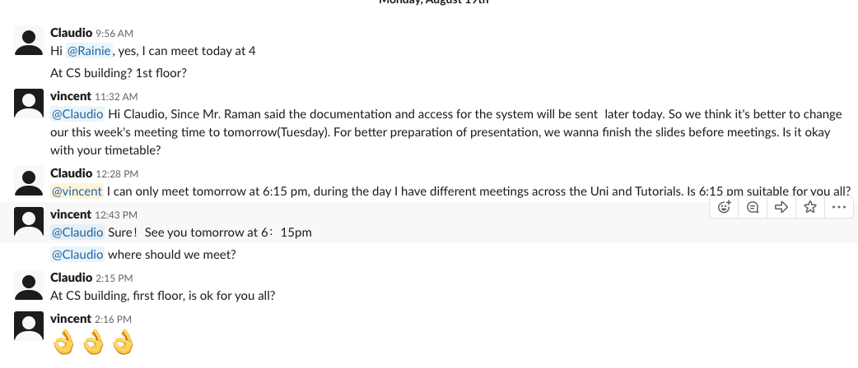

1. Finalize the weekly meeting with Mastt project team

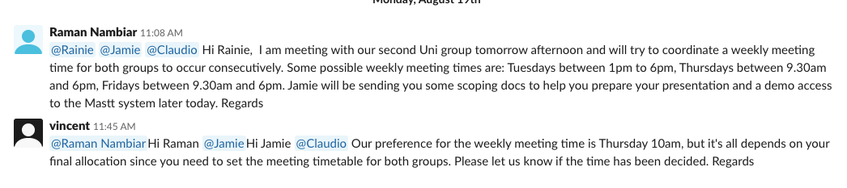

1. Setting and take part in the Trello work dashboard creation



1. Join the Brainstorm within the team

The Brainstorm is a summary of the current information about the Mastt project, which includes the assumption of the previous work and understanding, based on the meeting record.

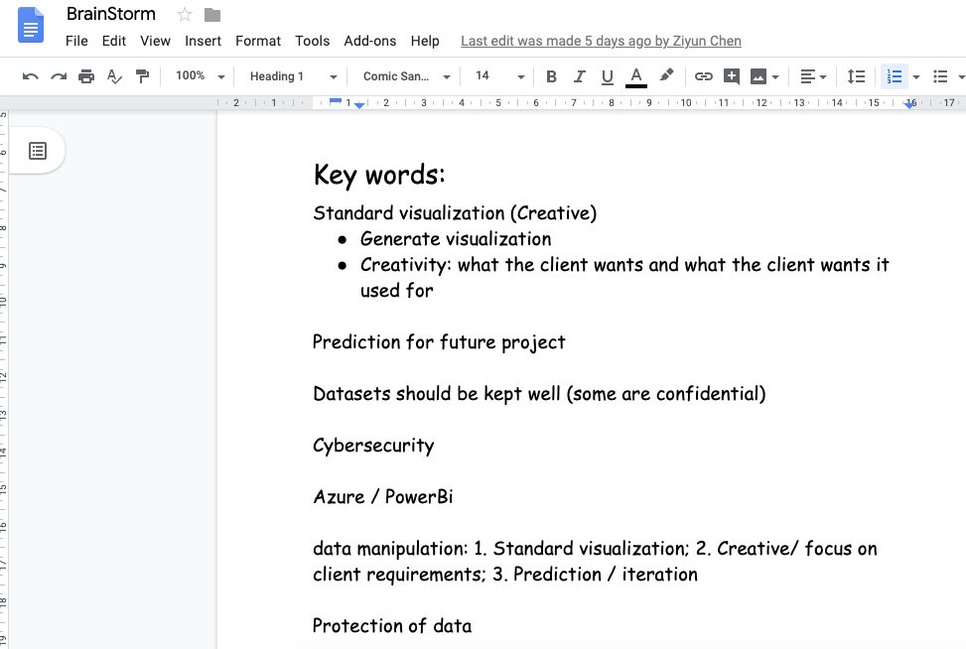

<https://docs.google.com/document/d/12q5LeeIGgRx3T54VjO1ziXYQETR3Kc5plGzLt6xGVVQ/edit?usp=sharing>

1. Finish the kick-off slide

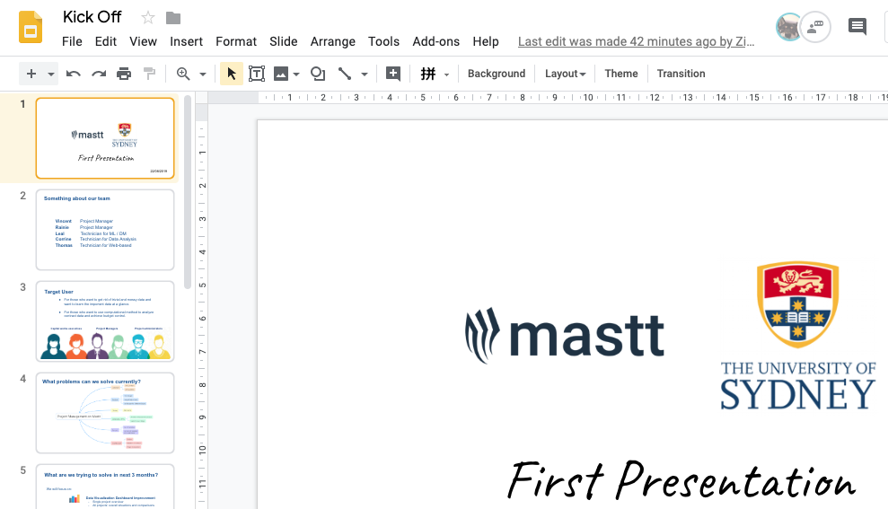

<https://docs.google.com/presentation/d/1uXzLIXWV7vzuskgFZEq4uxGEBZ8T-hN010CKG8V5sPo/edit?usp=sharing>

# **4.** **Group Collaboration**

1. Cooperate to finish the Trello dashboard, in order to plan project timeline better

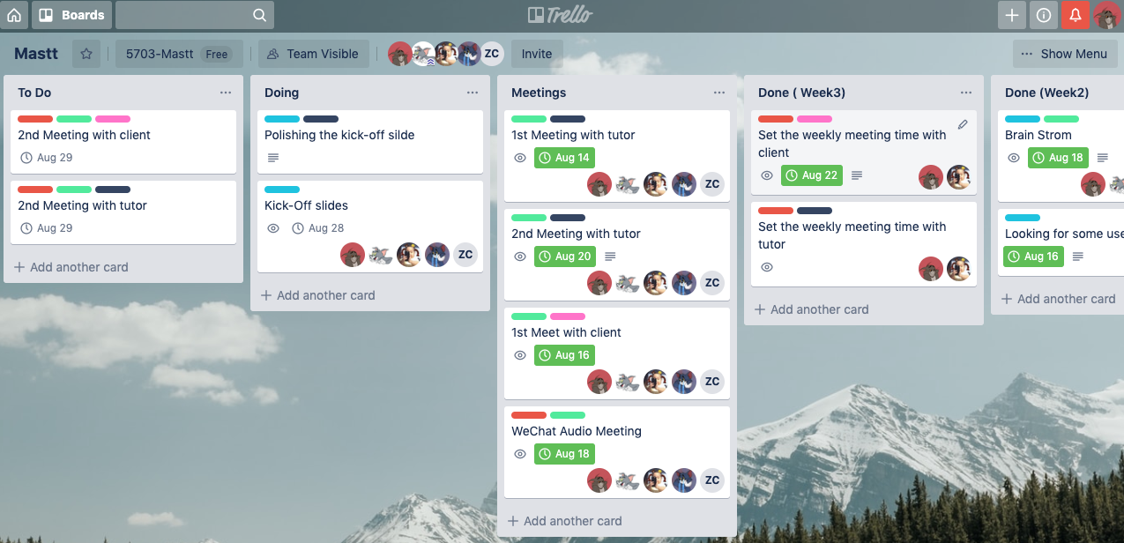

1. Established the Slack channel with both client and tutor

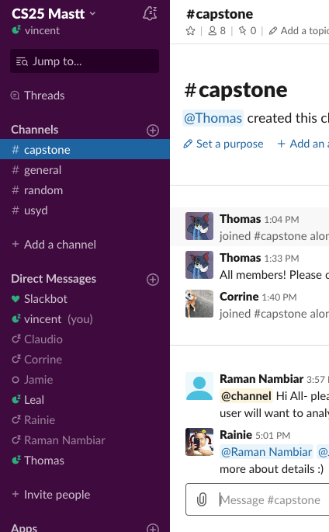

1. Two group meetings via Wechat voice chat and physically.

